NAME: Gundupalli Srujan Deep

REG:192125009

Subject:CSA0978-Programming in Java

1.

import java.awt.Color;

import java.awt.FlowLayout;

import java.awt.Font;

import javax.swing.JFrame;

import javax.swing.JLabel;

public class colourchange extends JFrame implements Runnable {

private JLabel label;

public colourchange() {

super("Color Changer");

setDefaultCloseOperation(JFrame.*EXIT_ON_CLOSE*);

setLayout(new FlowLayout());

label = new JLabel("Welcome to Color Changer!");

label.setFont(new Font("Arial", Font.*BOLD*, 20));

add(label);

pack();

setLocationRelativeTo(null);

setVisible(true);

}

@Override

public void run() {

try {

while (true) {

Color color = new Color((int) (Math.*random*() * 0x1000000));

label.setForeground(color);

Thread.*sleep*(500);

}

} catch (InterruptedException ex) {

ex.printStackTrace();

}

}

public static void main(String[] args) {

colourchange colorChanger = new colourchange();

Thread thread = new Thread(colorChanger);

thread.start();

}

}

2.

public class multiplicationtable implements Runnable {

private int number;

public multiplicationtable(int number) {

this.number = number;

}

@Override

public void run() {

try {

System.*out*.println(Thread.*currentThread*().getName() + " is in the running state.");

for (int i = 1; i <= 10; i++) {

System.*out*.println(number + " x " + i + " = " + (number * i));

Thread.*sleep*(500);

}

} catch (InterruptedException ex) {

ex.printStackTrace();

}

System.*out*.println(Thread.*currentThread*().getName() + " has completed its task.");

}

public static void main(String[] args) {

multiplicationtable table5 = new multiplicationtable(5);

multiplicationtable table10 = new multiplicationtable(10);

Thread thread1 = new Thread(table5);

thread1.setName("Thread 1");

System.*out*.println("Thread 1 is in the new state.");

thread1.start();

Thread thread2 = new Thread(table10);

thread2.setName("Thread 2");

System.*out*.println("Thread 2 is in the new state.");

thread2.start();

}

}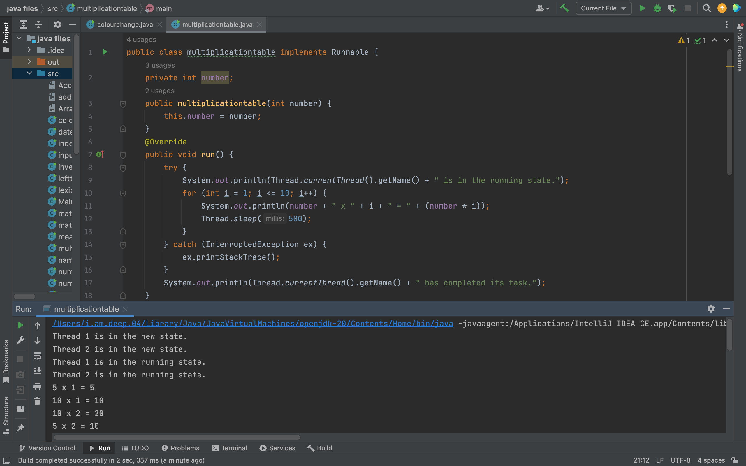

3.

import java.util.*;

public class uglynumber {

public static boolean isUgly(int n) {

if (n <= 0) {

return false;

}

while (n % 2 == 0) {

n /= 2;

}

while (n % 3 == 0) {

n /= 3;

}

while (n % 5 == 0) {

n /= 5;

}

return n == 1;

}

public static void main(String[] args) {

Scanner sc = new Scanner(System.*in*);

System.*out*.print("Enter an integer: ");

int n = sc.nextInt();

sc.close();

boolean isUglyNumber = *isUgly*(n);

System.*out*.println(n + " is an ugly number: " + isUglyNumber);

}

}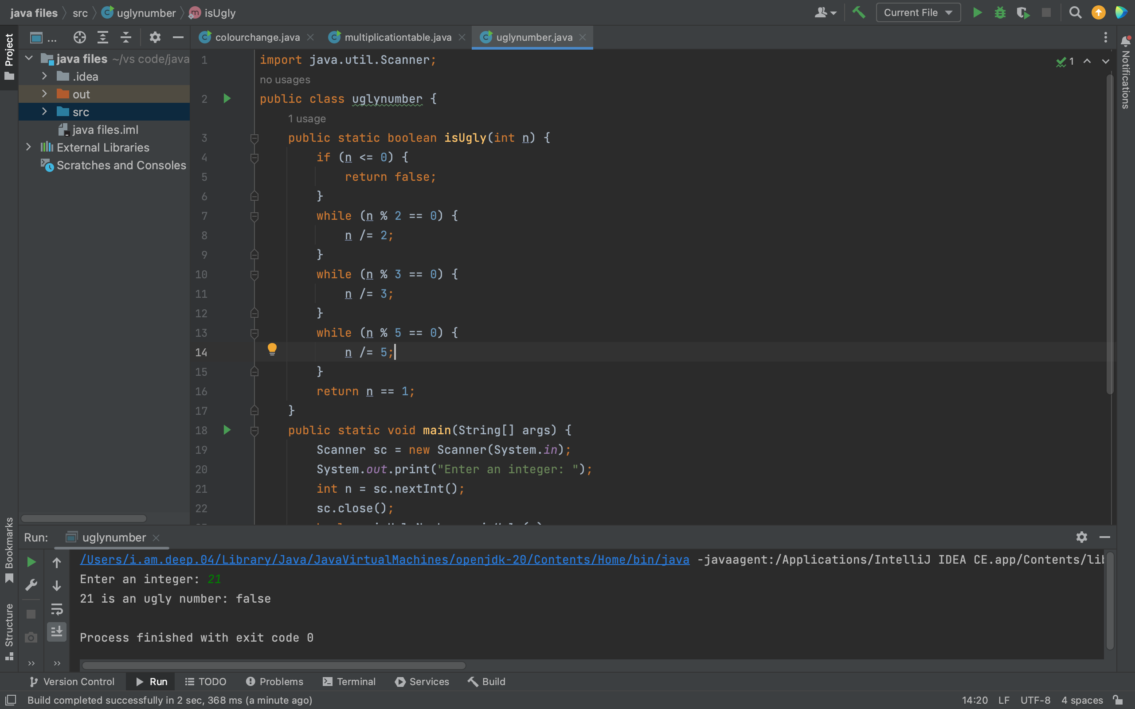

4.

import java.util.*;

public class fibonacci {

public static int fib(int n) {

if (n <= 1) {

return n;

}

int prev1 = 0, prev2 = 1, fib = 0;

for (int i = 2; i <= n; i++) {

fib = prev1 + prev2;

prev1 = prev2;

prev2 = fib;

}

return fib;

}

public static void main(String[] args) {

Scanner sc = new Scanner(System.*in*);

System.*out*.print("Enter a value for n: ");

int n = sc.nextInt();

int fibonacci = *fib*(n);

System.*out*.println("Fibonacci number at position " + n + ": " + fibonacci);

}

}

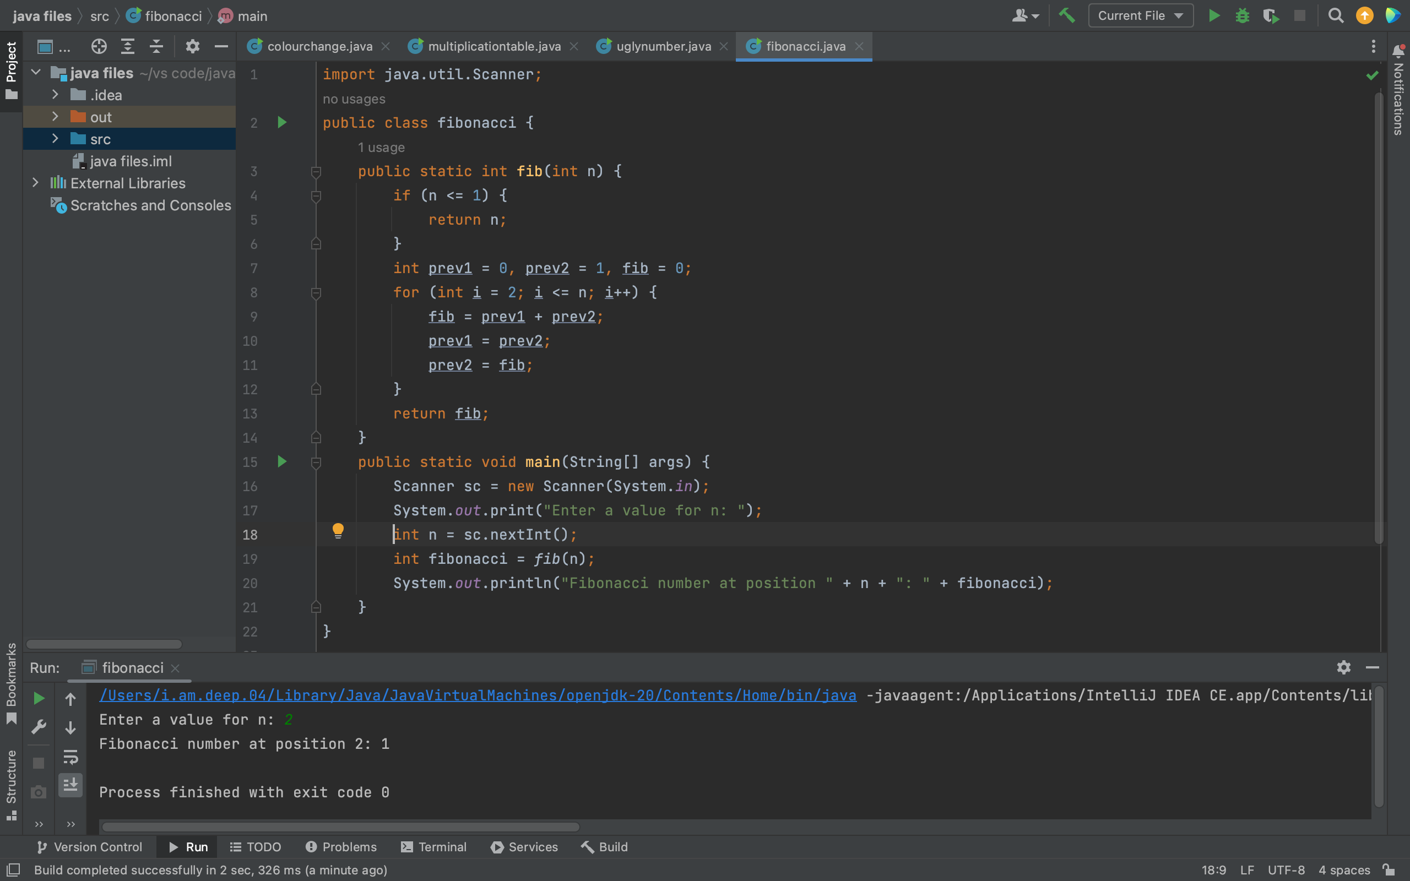

5.

class duplicate {

// Function to remove duplicate elements

// This function returns new size of modified

// array.

static int removeDuplicates(int arr[], int n) {

// Return, if array is empty

// or contains a single element

if (n == 0 || n == 1)

return n;

int[] temp = new int[n];

// Start traversing elements

int j = 0;

for (int i = 0; i < n - 1; i++) { // corrected loop variable name and added missing curly braces

// If current element is not equal

// to next element then store that

// current element

if (arr[i] != arr[i+1])

temp[j++] = arr[i];

}

// Store the last element as whether

// it is unique or repeated, it hasn't

// stored previously

temp[j++] = arr[n-1];

// Modify original array

for (int i = 0; i < j; i++)

arr[i] = temp[i];

return j;

}

public static void main (String[] args) {

int arr[] = {10, 20, 20, 30, 40, 40, 40, 50, 50};

int n = arr.length;

n = *removeDuplicates*(arr, n); // corrected method call

// Print updated array

for (int i = 0; i < n; i++)

System.*out*.print(arr[i] + " ");

}

}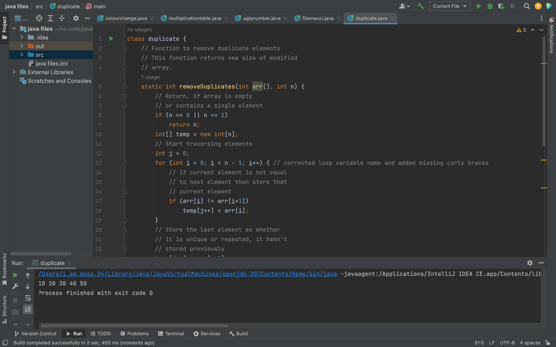

6.

import java.util.*;

public class reverse {

public static void main(String[] args) {

Scanner input = new Scanner(System.*in*);

System.*out*.print("Enter a word: ");

String word = input.next();

String reversed = "";

for (int i = word.length() - 1; i >= 0; i--) {

reversed += word.charAt(i);

}

System.*out*.println("Reversed word: " + reversed);

}

}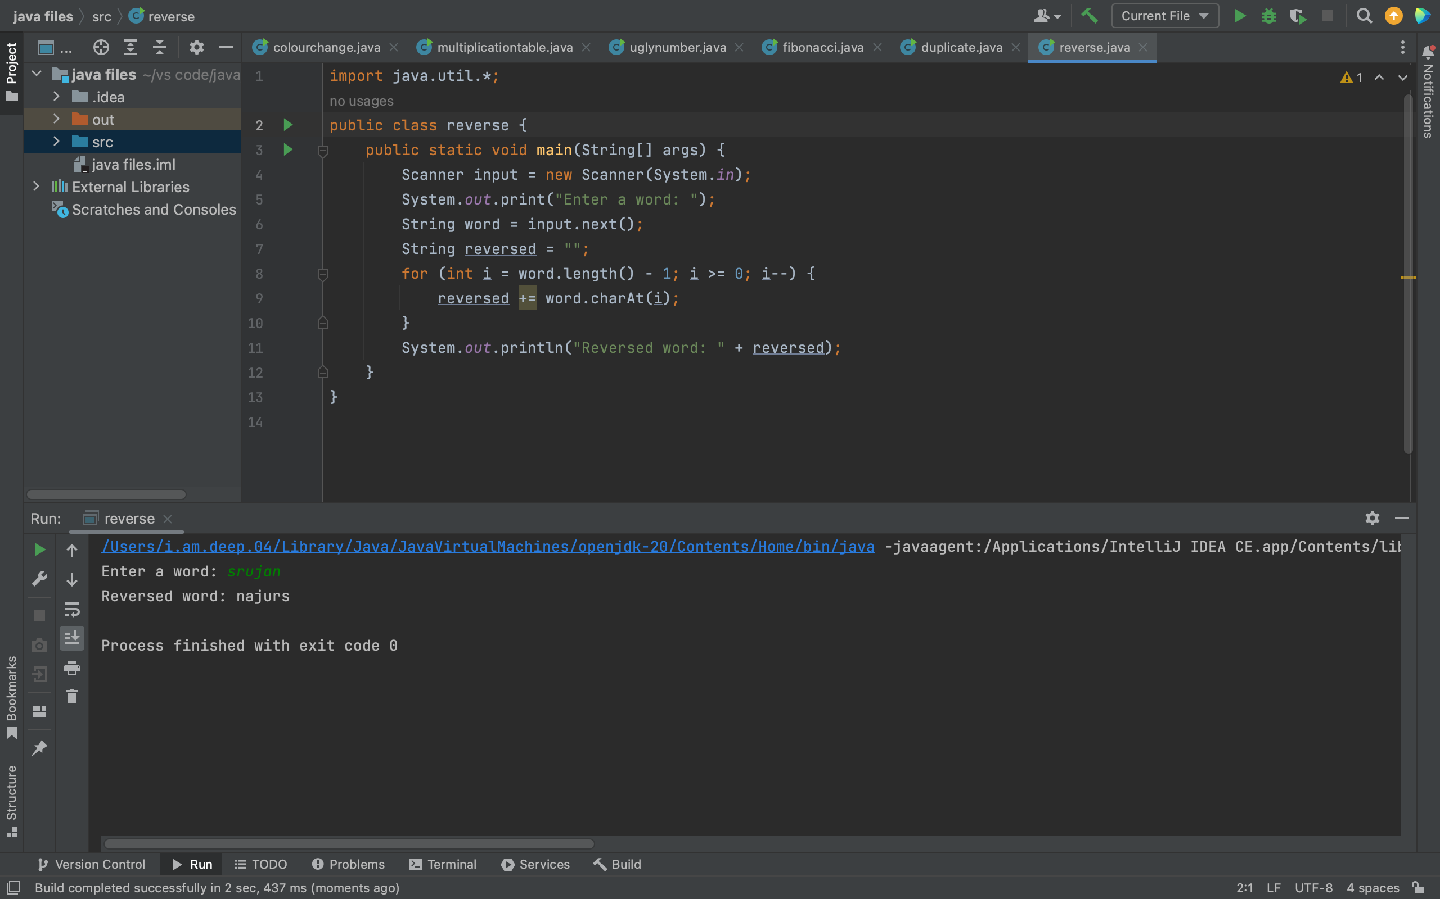

7.

import java.util.*;

public class stringtointeger {

public static void main(String[] args) {

Scanner scanner = new Scanner(System.*in*);

System.*out*.print("enter a string: ");

String stringInput = scanner.nextLine();

int integerOutput = Integer.*parseInt*(stringInput);

System.*out*.println("the integer equivalent of the string is: " + integerOutput);

}

}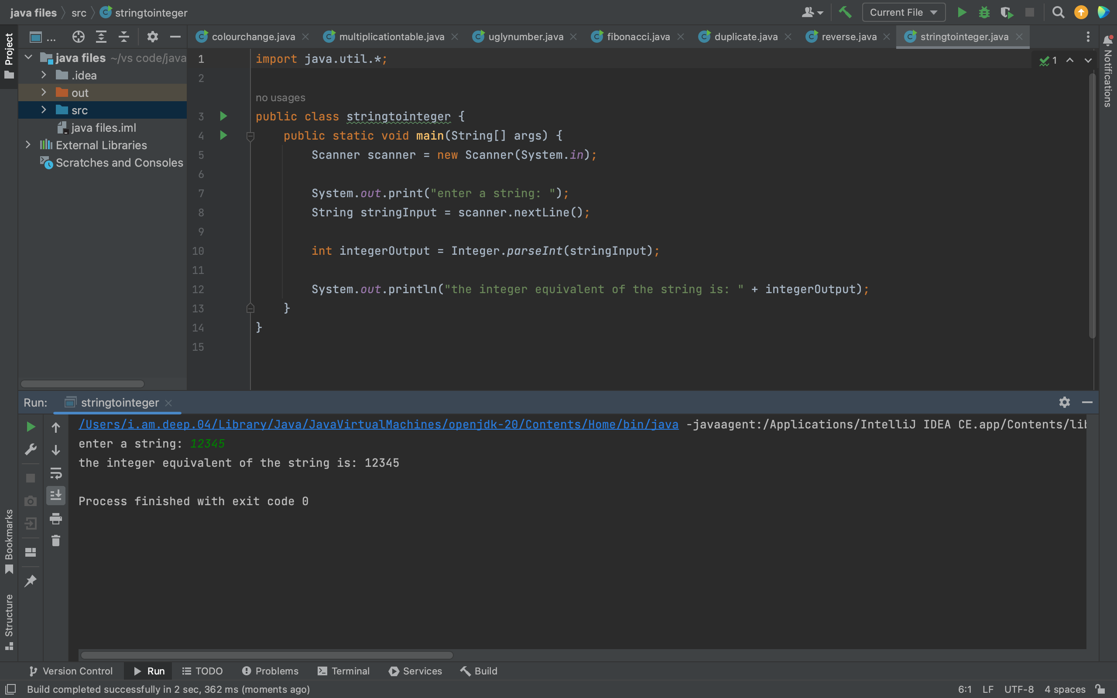

8.

import java.util.*;

public class usernamevalidation {

public static void main(String[] args) {

Scanner scanner = new Scanner(System.*in*);

System.*out*.print("enter a username: ");

String username = scanner.nextLine();

boolean isValid = *validateUsername*(username);

if(isValid) {

System.*out*.println("the username is valid.");

} else {

System.*out*.println("the username is not valid.");

}

}

public static boolean validateUsername(String username) {

int length = username.length();

if(length < 4 || length > 16) {

return false;

}

for(int i = 0; i < length; i++) {

char c = username.charAt(i);

if(!Character.*isLetterOrDigit*(c) && c != '_' && c != '-') {

return false;

}

}

return true;

}

}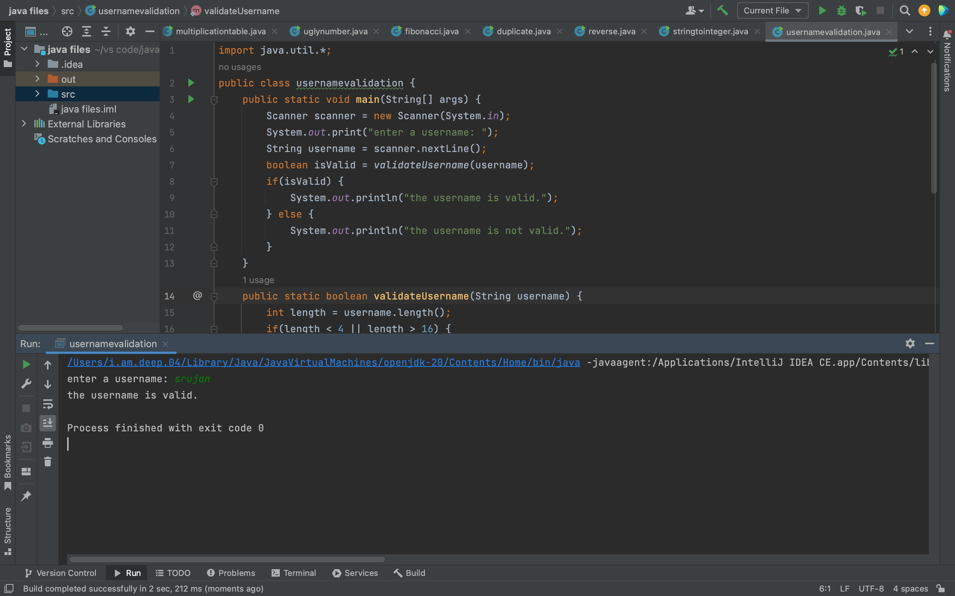

9.

import java.util.ArrayList;

import java.util.Collections;

import java.util.Scanner;

public class alphabeticalorder {

public static void main(String[] args) {

Scanner scanner = new Scanner(System.*in*);

System.*out*.print("enter the number of names: ");

int n = scanner.nextInt();

scanner.nextLine();

ArrayList<String> names = new ArrayList<>();

for(int i = 0; i < n; i++) {

System.*out*.print("Enter name " + (i+1) + ": ");

String name = scanner.nextLine();

names.add(name);

}

System.*out*.print("enter sorting order (asc/desc): ");

String sortOrder = scanner.nextLine();

if(sortOrder.equalsIgnoreCase("asc")) {

Collections.*sort*(names);

System.*out*.println("names sorted in ascending order: " + names);

} else if(sortOrder.equalsIgnoreCase("desc")) {

Collections.*sort*(names, Collections.*reverseOrder*());

System.*out*.println("names sorted in descending order: " + names);

} else {

System.*out*.println("invalid sorting order.");

}

}

}

10.

import java.util.*;

public class specialcharacter {

public static void main(String[] args) {

Scanner scanner = new Scanner(System.*in*);

System.*out*.print("enter a line of text: ");

String line = scanner.nextLine();

int specialCount = 0;

System.*out*.println("special characters in the line:");

for(char c : line.toCharArray()) {

if(!Character.*isLetterOrDigit*(c) && !Character.*isWhitespace*(c)) {

System.*out*.println(c);

specialCount++;

}

}

System.*out*.println("number of special characters: " + specialCount);

}

}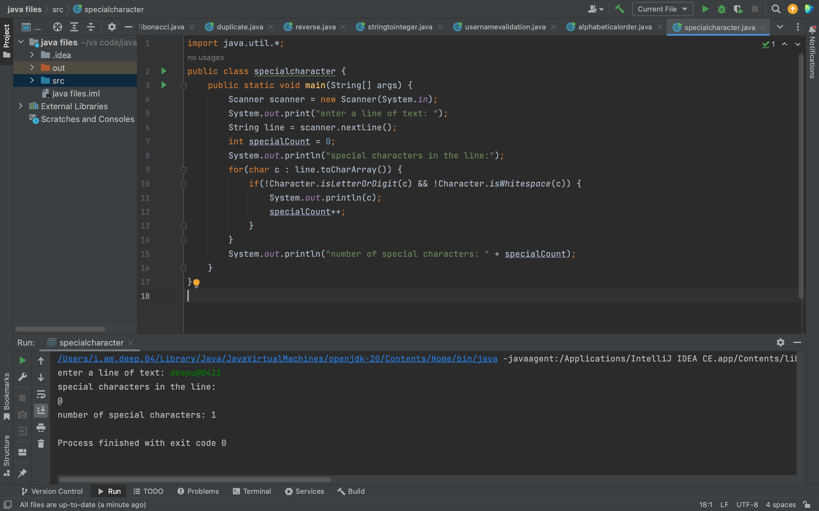

11.

import java.util.*;

public class vowels {

public static void main(String[] args) {

Scanner scanner = new Scanner(System.*in*);

System.*out*.print("Enter a statement: ");

String statement = scanner.nextLine();

int vowelCount = 0;

for(char c : statement.toCharArray()) {

if(*isVowel*(c)) {

vowelCount++;

}

}

System.*out*.println("Number of vowels in the statement: " + vowelCount);

}

public static boolean isVowel(char c) {

c = Character.*toLowerCase*(c);

return c == 'a' || c == 'e' || c == 'i' || c == 'o' || c == 'u';

}

}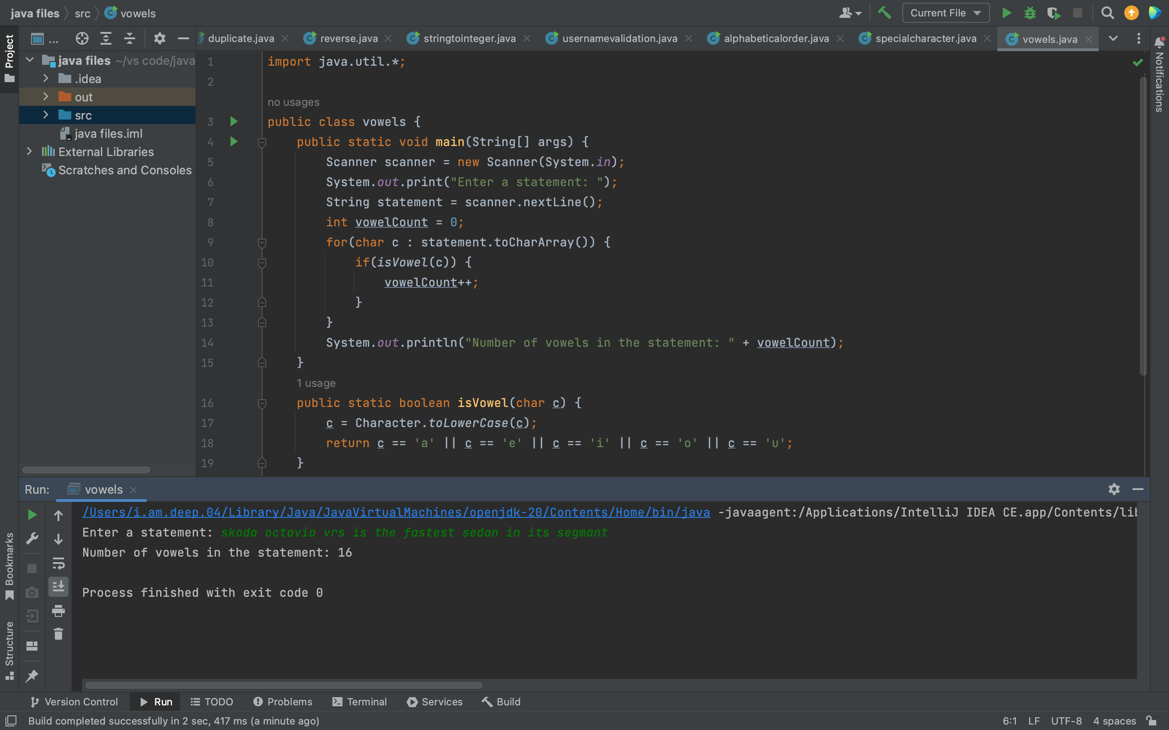

12.

import java.util.*;

public class vowelsandconsonents {

public static void main(String[] args) {

Scanner scanner = new Scanner(System.*in*);

System.*out*.print("enter a word: ");

String word = scanner.nextLine();

String consonants = "";

String vowels = "";

for(char c : word.toCharArray()) {

if(*isVowel*(c)) {

vowels += c;

} else {

consonants += c;

}

}

System.*out*.println("consonants in the word: " + consonants);

System.*out*.println("vowels in the word: " + vowels);

}

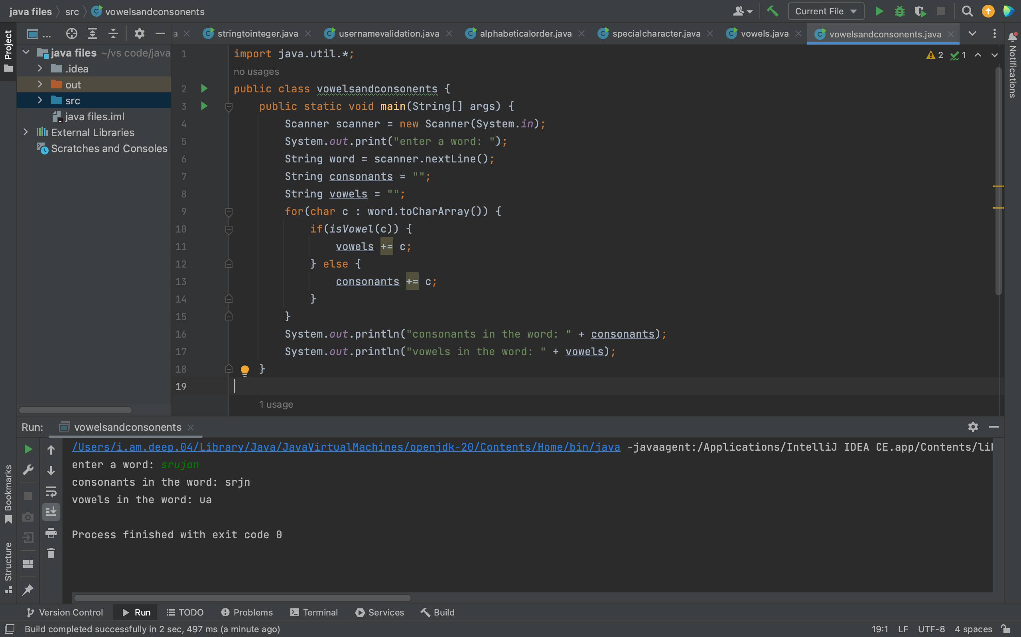

13.

import java.util.*;

public class findcharacter {

public static void main(String[] args) {

Scanner scanner = new Scanner(System.*in*);

System.*out*.print("enter a string: ");

String string = scanner.nextLine();

System.*out*.print("enter a character to search: ");

char character = scanner.next().charAt(0);

int index = -1;

for(int i = 0; i < string.length(); i++) {

if(string.charAt(i) == character) {

index = i;

break;

}

}

if(index == -1) {

System.*out*.println("the character " + character + " is not present in the string.");

} else {

System.*out*.println("the character " + character + " is present in the string at index " + index + ".");

}

}

}

14.

import java.util.Arrays;

import java.util.*;

public class reverseorder{

public static void main(String[] args) {

Scanner scanner = new Scanner(System.*in*);

System.*out*.print("enter a word: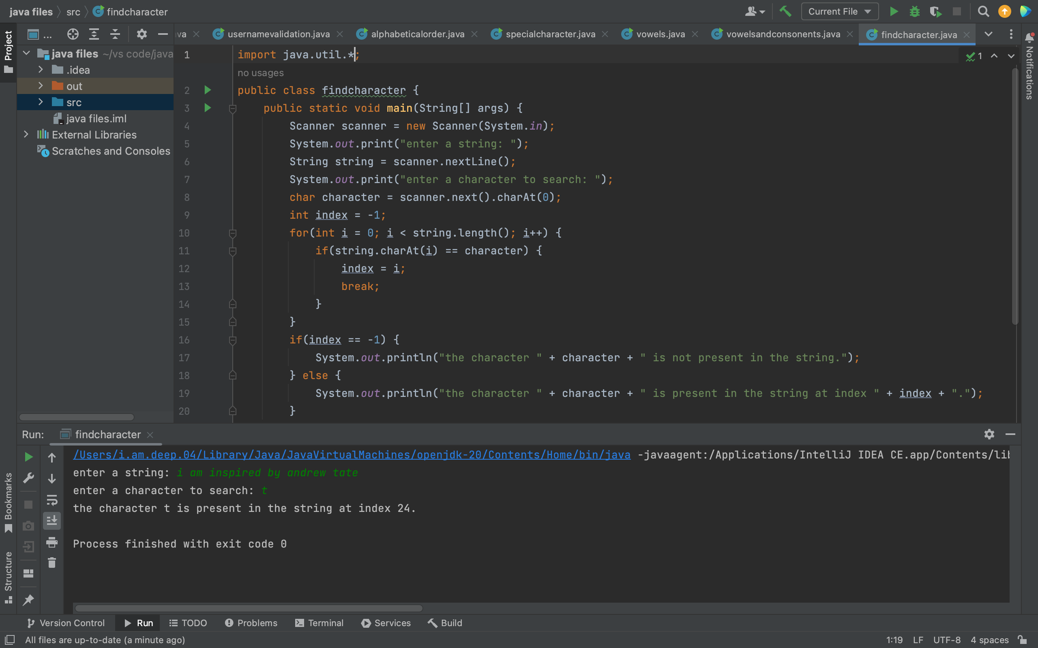 ");

String word = scanner.next();

char[] letters = word.toCharArray();

Arrays.*sort*(letters);

for(int i = letters.length - 1; i >= 0; i--) {

System.*out*.print(letters[i]);

}

}

}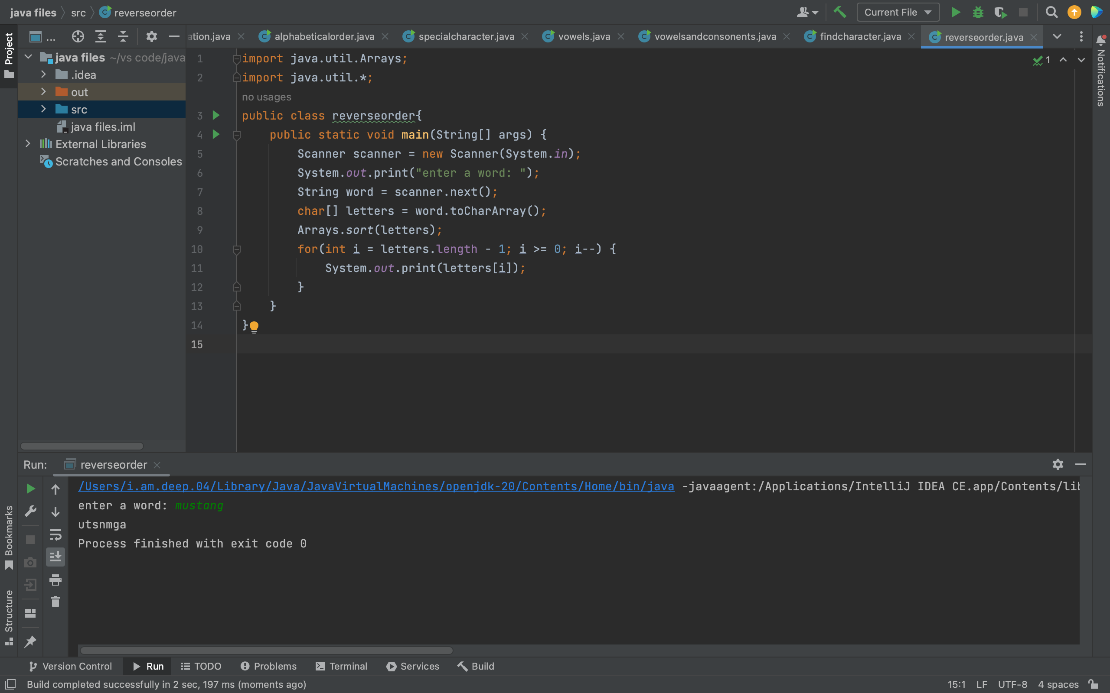

15.

import java.util.*;

public class removevowels {

public static void main(String[] args) {

Scanner scanner = new Scanner(System.*in*);

System.*out*.print("enter a string: ");

String string = scanner.nextLine();

String newString = string.replaceAll("[AEIOUaeiou]", "");

System.*out*.println("new string after removing vowels: " + newString);

}

}